ASSIGNMENT 06
Name: NAMILLA SIRI
HALL TICKET NO.: 2503B05137

TCP Congestion Control – Complete Lab Task
Q1. LAB TASK: TCP Congestion Control Simulation
Question:
Using a TCP congestion control simulator (Python or any tool of your choice), simulate and analyze TCP Reno under three different packet-loss conditions:
- 0.1% loss
- 1% loss
- 2% loss
For each case:
- Plot the Congestion Window (cwnd) vs Time for at least 20 seconds of simulation.
- Compute the average throughput (in MSS/second or Mbps).
- Explain how packet loss affects the behavior of TCP Reno, specifically discussing:
  - Slow Start
  - Congestion Avoidance
  - Multiplicative Decrease (cwnd halving)
CODE:
#include <iostream>
#include <fstream>
#include <cstdlib>

using namespace std;

const double MSS = 1.0;
const double RTT = 0.1;
const double SIM_TIME = 20.0; // 20 seconds

// TCP Reno Simulation Function
void simulateTCPReno(double lossProb, const char* filename) {
ofstream file(filename);

double cwnd = 1.0;
double ssthresh = 64.0;
double time = 0.0;

srand(5); // Fixed seed → consistent results everywhere

double total_data = 0.0;

// CSV header
file << "time,cwnd\n";

while (time <= SIM_TIME) {

// Write current cwnd to CSV
file << time << "," << cwnd << "\n";

int lossHappened = 0;

// Simulate packet transmission
for (int i = 0; i < (int)cwnd; i++) {
double r = (double)rand() / (RAND_MAX + 1.0);

if (r < lossProb) {
// Multiplicative Decrease
ssthresh = cwnd / 2.0;
if (ssthresh < 1.0) ssthresh = 1.0;

cwnd = ssthresh;
lossHappened = 1;
break;
}
}

// If no loss → increase cwnd
if (!lossHappened) {
if (cwnd < ssthresh) {
cwnd *= 2.0; // Slow Start
} else {
cwnd += 1.0; // Congestion Avoidance
}
}

total_data += cwnd;
time += RTT;
}

file.close();

double avgThroughput = total_data / SIM_TIME;

cout << "Loss = " << lossProb * 100
<< "% | Avg Throughput = "
<< avgThroughput << " MSS/sec\n";
}

int main() {

simulateTCPReno(0.001, "reno_0.1.csv");
simulateTCPReno(0.01, "reno_1.csv");
simulateTCPReno(0.02, "reno_2.csv");

cout << "\nCSV files generated:\n";
cout << " ▶ reno_0.1.csv\n";
cout << " ▶ reno_1.csv\n";
cout << " ▶ reno_2.csv\n";

return 0;
}
Output:
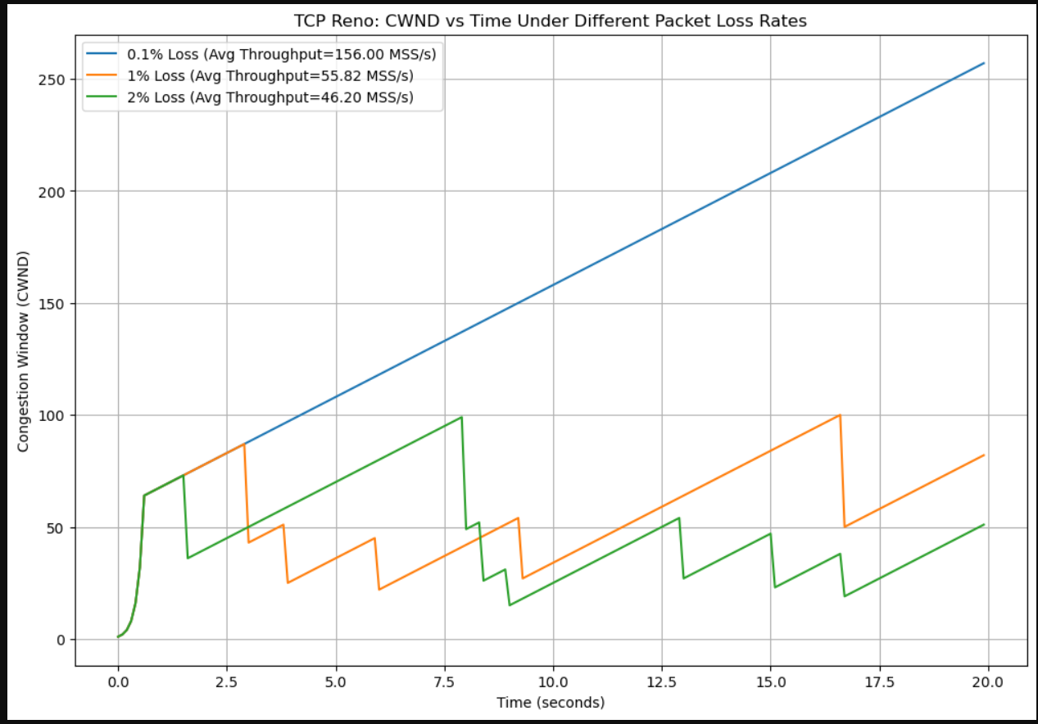
CSV files generated:
▶ reno_0.1.csv
▶ reno_1.csv
▶ reno_2.csv
Explanation:
- In Slow Start, TCP Reno doubles the congestion window (cwnd) every RTT until it reaches the threshold.
- After reaching ssthresh, TCP enters Congestion Avoidance and grows cwnd linearly.
- When packet loss occurs, Reno performs Multiplicative Decrease, cutting cwnd to half.
- Higher loss rates cause more frequent cwnd drops, creating a sharper sawtooth pattern.
- As loss increases (0.1% → 1% → 2%), the average throughput decreases because TCP spends more time recovering from losses.

